1. Project Title
Rule-Based AI Chatbot
2. Objective
To create a simple rule-based AI chatbot that responds to predefined user inputs using Python.
3. Technologies Used
- Python
- Jupyter Notebook
- Dictionary
- While Loop
- Conditional Statements
4. Key Features
- Greeting responses
- Predefined question responses
- Continuous conversation
- Unknown-input fallback
- Exit using bye, exit, or quit
5. Project Screenshot
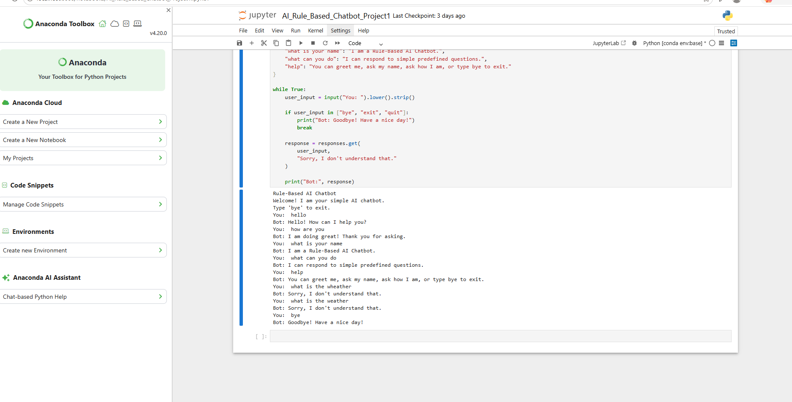
6. Working / Methodology
The chatbot takes input from the user and converts it into lowercase format and removes extra spaces. It then checks the user input against predefined responses stored in a dictionary. If a matching input is found, the chatbot displays the corresponding response. If the input is not recognized, it displays a fallback message. The conversation continues until the user enters bye, exit, or quit.

7. Testing
User Input | Chatbot Response
hello | Hello! How can I help you?
how are you | I am doing great! Thank you for asking.
what is your name | I am a Rule-Based AI Chatbot.
what can you do | I can respond to simple predefined questions.
help | You can greet me, ask my name, ask how I am, or type bye to exit.
what is the weather | Sorry, I don't understand that.
bye | Goodbye! Have a nice day!

8. Conclusion
This project helped me understand the basic concepts of Artificial Intelligence and rule-based decision making. I learned how to use Python dictionaries, conditional logic, user input, and loops to create a simple chatbot. The chatbot can handle predefined user questions, provide a fallback response for unknown inputs, and continue the conversation until the user exits.

9. Key Learning Outcomes
Add these points:
- Understanding basic rule-based AI concepts
- Using Python dictionaries for predefined responses
- Using if-else logic for decision making
- Using a while loop for continuous interaction
- Handling and cleaning user input
- Providing fallback responses
- Handling chatbot exit commands

10. Future Improvements
The chatbot can be improved by adding more questions and responses, more intents, better natural language processing, and a more interactive personality. It can also be connected with external APIs in future projects.

